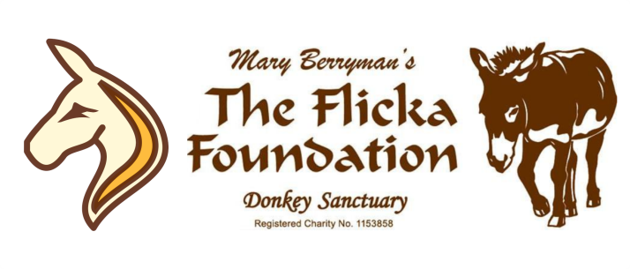

VOLUNTEER APPLICATION FORM
Thank you for your interest in becoming a volunteer at The Flicka Foundation Donkey Sanctuary
Please consider volunteering carefully – the Foundation relies heavily on donated time. If you are serious and committed to animal welfare and their long term care, we’d love to hear from you!
Name:

Post Code:
Address:

Landline: Mobile:

Email Address:

Date of Birth: Do you have your own transport? Yes / No

Which volunteer role would you like to do? You can tick more than one option
Mucking / Skipping Out: Daily 9am to 12noon. Physical work.
Sweeping and cleaning the Sanctuary areas: All day, every day!
Poo Picking: Daily11am - 1pm and 2pm - 4pm. Physical work.
Grooming Donkeys & Horses:* 2pm to 4pm daily. Training will be given. *A perk once volunteering
Tea Room Helper: When open to visitors. 11am – 4pm. Clearing tables and washing up
Meet & Greet Helper: When open to visitors. 11am – 4pm. Greeting visitors with a smile!
Gift Shop Helper: When open to visitors. 11am – 4pm. Taking payment. Training will be given.
Fundraising Events & Baking: Ad Hoc. To represent Flicka at external events. Cake baking etc.
Maintenance & gardening: Ad Hoc. Repairs, painting and weeding.
On which days and when are you able to help? You can tick more than one box
Monday am pm Tuesday am pm Wednesday am pm Thursday am pm
Friday am pm Saturday am pm Sunday am pm

Please tell us why you would like to volunteer at the sanctuary and any experience you have:
_______________________________________________________________________________________________
_______________________________________________________________________________________________

The Flicka Foundation Volunteer Policy
Due to the large number of volunteer applications we receive it is necessary for us to put together a Volunteer Policy. If this policy is not in line with what you had hoped volunteering is about then you may like to enquire about ‘Casual Volunteers’, ‘Temporary Volunteers’ or ‘Student Volunteers’.
(Please email centremanager@flicka.org.uk or volunteer@flicka.org.uk for details)
We have a large number of applicants for volunteering; the sanctuary needs good, reliable and committed volunteers. Please only apply if you are committed; once you are on the charity’s volunteer database you will come under the liability insurance.
As a volunteer you will be expected to volunteer a minimum of 14 hours per calendar month with days and times arranged in advance.
Applicants who do not attend an arranged induction with no prior notification will be removed from the database.
Volunteers who do not attend for a month following an induction will be removed from the database.
Due to insurance specifications regarding volunteer numbers, volunteers who do not attend on three consecutive occasions with no prior notification will be removed from the database.
Please notify the charity if you do not wish to volunteer following an induction or wish to cease volunteering.
volunteer@flicka.org.uk
www.flickafoundation.org.uk
01326 373601

-----------------------------------------------------------------------------------------------------------------------------------------------
I have read and understood the Volunteer Policy and would like to be considered for volunteer work at the sanctuary.
You will be contacted shortly with an invitation to attend a general induction which lasts approximately 20-30 minutes and includes health and safety procedures.

Signed................................................................................Date.......................................................................

PRINT Name......................................................................................................................................................

Thank You FLICKA

