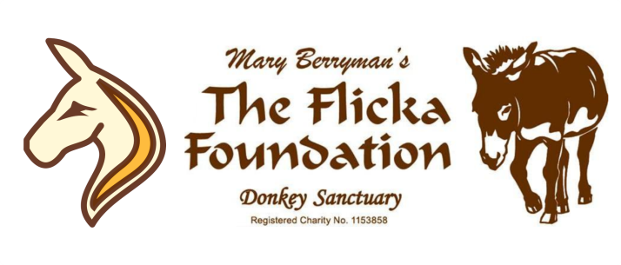
YARD VOLUNTEER
APPLICATION FORM

Thank you for your interest in becoming a volunteer at The Flicka Foundation Donkey Sanctuary!
Please consider your offer of volunteering very carefully – we rely heavily on donated time. If you are serious and committed to the donkeys and helping with their day to day care, we’d love to hear from you! Please note the main role of the Yard Volunteer will be mucking and sweeping out and won’t be hands on with the Donkeys.
Name:

Post Code:
Address:

Landline: Mobile:

Email Address:

Date of Birth: Do you have your own transport? Yes / No

We have a limited number of volunteer slots available, please ONLY tick the slots you can attend:
□ Mon 9:00-12:00
□ Tuesday 9:00-12:00
□ Wednesday 9:00-12:00
□ Thursday 9:00-12:00
□ Friday 9:00-12:00
□ Saturday 9:00-12:00
□ Sunday 9:00-12:00

Please tell us why you would like to volunteer at the sanctuary and any experience you have: ______________________________________________________________________________________________________________________________________________________________________________________________________________________________________________________________________________________________________
Please explain how and why you are committed to volunteering for us: ______________________________________________________________________________________________________________________________________________________________________________________________________________________________________________________________________________________________________
If there is anything you feel we should know that might affect your ability to perform tasks that are intrinsic to this role, please let us know in advance.
--------------------------------------------------------------------------------------------------------------------------------------------------------------
The Flicka Foundation Volunteer Policy
Due to the large number of volunteer applications we receive, it is necessary for us to have a Volunteer Policy. If this policy is not in line with what you had hoped, then you may want to reconsider your application.
We have a large number of applicants for volunteering; the sanctuary needs good, reliable and committed volunteers. Please only apply if you are committed; once you are on our charity’s volunteer database you will come under the liability insurance.
As a volunteer you will be expected to volunteer a minimum of 12 hours per calendar month with days and times arranged in advance.
Applicants who do not attend an arranged induction with no prior notification will be removed from the database.
Volunteers who do not attend to volunteer for a month following an induction will be removed from the database.
Due to insurance specifications regarding volunteer numbers, volunteers who do not attend on three consecutive occasions with no prior notification will be removed from the database.
Please notify the charity if you do not wish to volunteer following an induction or wish to cease volunteering.
volunteers@flicka.org.uk
www.flickafoundation.org.uk
01326 373601
-----------------------------------------------------------------------------------------------------------------------------------------------
I have read and understood the Volunteer Policy and would like to be considered for volunteer work at the sanctuary.
You may be contacted shortly to attend an informal interview to discuss your interest further. Please note, due to the volume of applications received, we are not able to contact, or offer individual feedback on, unsuccessful applications - thank you for your understanding.

Signed ................................................................................ Date ....................................................................
PRINT Name ....................................................................... Thank You! Flicka

