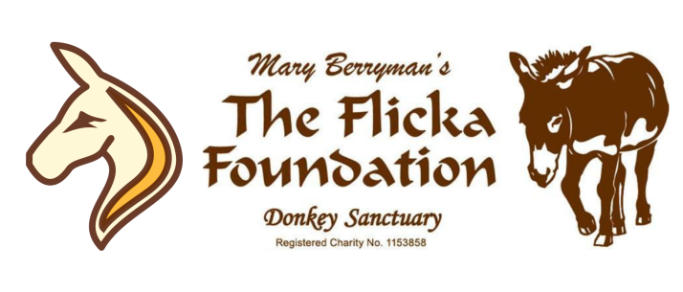
WORK EXPERIENCE
APPLICATION FORM

Thank you for your interest in undertaking your work experience at The Flicka Foundation!
Please consider your offer of volunteering very carefully – we rely heavily on donated time. If you are serious and committed to the donkeys and helping with their day to day care, we’d love to hear from you!

Name:

Post Code:
Address:

Landline: Mobile:

Email Address:

Date of Birth: Do you have your own transport? Yes / No

Why would you like to carry out work experience with us and what experience do you have?:
_____________________________________________________________________________________________________________________________________________________________________________________________________________________________________________________________________________________________
Is this a one week placement or extended period placement (i.e. one day a week)?
_______________________________________________________________________________________________
When would you like your work experience to take place?
_______________________________________________________________________________________________
What would you like to gain from your work experience? ______________________________________________________________________________________________________________________________________________________________________________________________
If there is anything you feel we should know that might affect your ability to perform tasks that are intrinsic to this role, please let us know in advance.

The Flicka Foundation Work Experience Policy
Due to the large number of work experience applications we receive, it is necessary for us to have this policy in place.
We have a large number of applications for work experience and the sanctuary needs good, reliable and committed volunteers. Please only apply if you are committed; once you are on the charity’s volunteer database you will come under the liability insurance.
Due to insurance specifications regarding volunteer numbers, we have limited work experience placements. If you no longer wish to attend your placement please let us know in advance, so we can offer it to someone else.
Due to the volume of applications received we are not able to contact or offer individual feedback on unsuccessful applications – thank you for your understanding.
If you are successful at this point you will be contacted to attend an informal interview and trial morning – this is to ensure the placement is a good fit for both yourself and the charity.
donkeys@flicka.org.uk
www.flickafoundation.org.uk
01326 373601

-----------------------------------------------------------------------------------------------------------------------------------------------
I have read and understood the Work Experience Policy and would like to be considered for Work Experience at the sanctuary.
You may be contacted shortly to attend an informal interview to discuss your interest further. Please note, due to the volume of applications received, we are not able to contact, or offer individual feedback on, unsuccessful applications - thank you for your understanding.

Signed................................................................................Date.......................................................................

PRINT Name......................................................................................................................................................

Thank You!
Flicka

