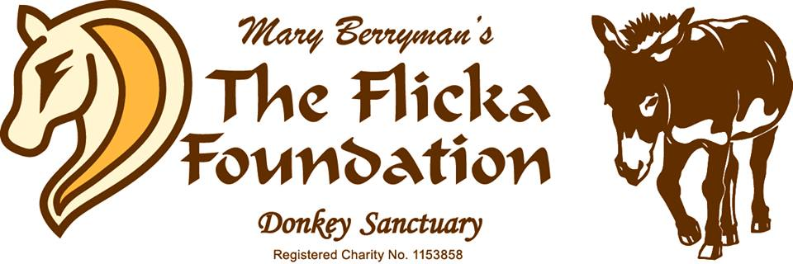

Penty Noweth Farm, Trenoweth Lane, Mabe Burnthouse,

Pemryn, Cornwall TR10 9JB

Tel: 01326 373601 Reg. Charity: 1153858
www.flickafoundation.org.uk

Adopt a Donkey

An adoption is £25 one off payment or from just £3 a month standing order
and includes a glossy folder, personalised certificate of adoption, photo and story of horse or donkey, our latest newsletter*, car sticker, wristband, pen, magnet and more!

Chosen horse/donkey name: ____________________________________________

- I enclose cheque/PO/cash for: _____________________________ (Amount)

- I have completed the Standing Order Form, to commence on: ________ (Date)
And thereafter on the same day each month, for the amount of: £________

I am a UK tax payer and wish to ‘Gift Aid’ my donation: YES NO
I understand that if I pay less Income Tax and/or Capital Gains Tax than the amount of Gift Aid claimed on all my donations in any given tax year, it is my responsibility to pay any difference. I will notify The Flicka Foundation of any changes to my name or address, or if I no longer pay sufficient tax and wish to cancel this declaration.

Please Print Clearly:

Name of Payer _______________________________________________

Full Postal Address ___________________________________________________

Post Code _____________________ Tel No ___________________________

Email address ______________________________
- Tick to receive e-news updates (donkey/horse updates, news, special appeals, events & more)
Name of Adopter* (name on certificate) ____________________________________

Full Postal Address ___________________________________________________

Post Code _____________________ Tel No ___________________________

Email address _______________________________
*If this adoption is a gift, please ensure you have the recipient’s permission to share their personal details with us

Date ________________________ Signed ______________________________

THANK YOU and welcome to our wonderful band of Adopters! Your adoption will contribute to the care of all the rescued donkeys and horses at our sanctuary.
*Your adoption includes receiving our bi-annual newsletter in the post - you can let us know at any time if you no longer want to receive direct mail from us.
Please visit our website or contact us for our Privacy Policy.

Penty Noweth Farm, Trenoweth Lane, Mabe Burnthouse,

Pemryn, Cornwall TR10 9JB

Tel: 01326 373601 Reg. Charity: 1153858
www.flickafoundation.org.uk

Adopt a Donkey – Standing Order Form

I/We would like to begin a monthly Standing Order;

Made Payable to: The Flicka Foundation Account Number: 63344234

Bank Name: Santander Sort Code: 09-01-28

Bank Address: Bridle Road, Bootle L30 4GB

Received from: (Your bank details)

Account _________________________ Account No. ____________________ (Please print clearly the name which is on your account)

Sort Code _____________________________

Bank Name & Address ________________________________________________

Post Code ___________________________

Account holders address _______________________________________________

Postcode _________________________________

------------------------------------------------------------------------------

I/We would like to pay by Standing Order to ‘The Flicka Foundation’ the sum of:

Amount in words ____________________________ Amount in figures ______________

On the _________________________(date) and on the same day of each month thereafter.

Your Signature ________________________________________

Date ______________________

Print Name __________________________________________________________

Please post these forms back to us and allow 14-21 days for us to put together and send your adoption pack. Thank you for your support!

